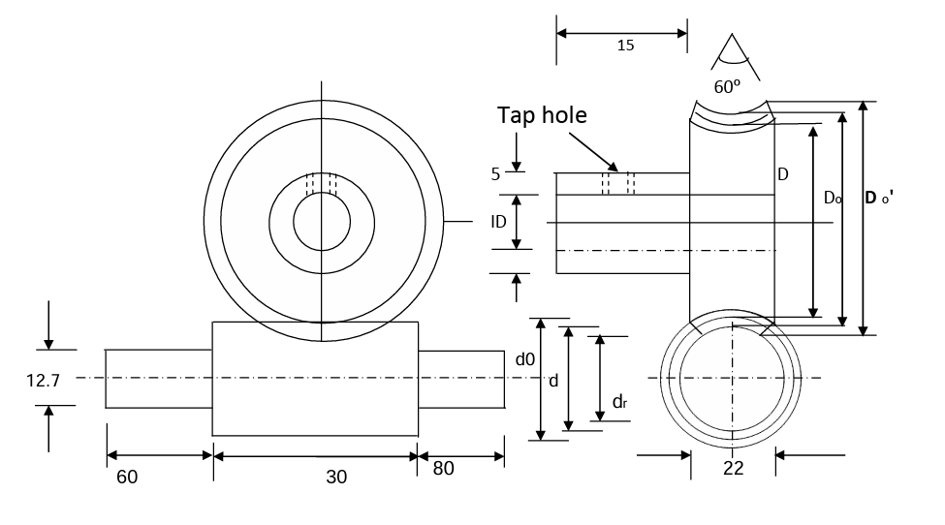 Quantity = 1

Module (M) = 1.5

Outer Diameter (OD) = 40

Rod diameter (ID) = 12.7

Tap hole =¼’’

No. of teeth (N) = 20

|  |  |
| --- | --- |
| **Part name:** Worm gear | |
| **Quantity:** 1 | **Scale:** 1:1 |
| **Material Required:** Metal | |

Part drawn by Samprit